**Smart Tech Solution Pvt. Ltd.**

Thapagaun, New Baneshwor

Kathmandu, Nepal

+977 - 01 - 5245027

**User Manual**

**For**

**Asset Management**

**Mobile Application**

# 

**1. Background**2

1.1 Assets 2

1.2. Maintenance 2

1.3. Service level 2

1.4. Asset Management 2

**2. Asset Management Plan**2

**3. Introduction**3

**4. Mobile Application**4

a. Cashbook 4

b. Maintenance 5

c. Service 5

**5. Using Mobile Application**5

5.1 Login 5

5.2 Mobile App Module 6

5.2.1 Cashbook 7

5.2.1.1 Add Income 7

5.2.1.2 Add Expenditure 8

5.2.1.3 Other functions in Cash Book 9

5.2.2 Maintenance 12

5.2.2.1 Preventive 13

5.2.2.2 Inspection 14

5.2.2.3 Reactive 16

5.2.1.3 Other functions in Maintenance 18

5.2.3 Service 19

5.2.3.1 Supply 20

5.2.3.2 Quality Tests 21

5.2 Notification 21

# 

# 1. Background

The asset management tools comprising a mobile app, a web dashboard, and a configuration panel are developed to support the management of assets and making asset management plans for water systems. To completely understand the concepts of asset management and the use of these tools, there is an entire e-learning platform that can be accessed at the following URL. <https://elearning.assetmgmttool.com/>

Following is a brief introduction to important concepts of asset management to help users understand different features of the tools while going through this manual.

## 1.1 Assets

An asset is a useful object or one of its components that is expected to provide benefits to the user, a person, or a company. For water systems, assets are the physical components of the system that allow for reliable, and safe water supply to the users. For example, wells, filtration units such as chlorination tanks, sedimentation tanks, roughing filters, hydrants, pipes, valves, bolts, overhead tanks, pumps, and household taps with meters.

## 1.2. Maintenance

Maintenance is the activity to ensure that assets keep on fulfilling their intended function during their full lifetime. Maintenance is important to reduce the risk of failure, ensure the system is reliable, and (in the case of water systems) provide clean water continuously to end-users.

## 1.3. Service level

The service level (SL) of a water system is the agreed quantity and quality of water supply during a certain time.

## 1.4. Asset Management

Asset management is the activity of maintaining the agreed service level during a sustained period of time at a certain cost.

# 2. Asset Management Plan

An Asset Management Plan is developed applying a community-led approach and supports stakeholders to ensure the required service level during a period of time. It includes:

1. An asset inventory

2. A risk assessment

3. A maintenance plan

4. An income and optimization analysis: A financial projection of what income (= water tariff and extra-governmental or charity contributions) is required to cover the costs for the agreed SL.

An Asset Management plan needs to be updated regularly since financial projections might not match reality, or some maintenance might be unforeseen and not included in the plan and cost estimates.

# 3. Introduction

Asset management tools for individual water system includes the following,

1. A mobile app

2. A web dashboard

3. A configuration panel

The mobile app is a password-protected application that allows operational staff members of the water system to view and add information on the water system. The web dashboard is a publicly accessible web link that presents information about the water system. The configuration panel is the password-protected data management area for the entire system. Data and settings for the water system can be managed from the configuration area.

When a new water system is added, a web dashboard link and a user for configuration panel is created. Users for mobile applications can be then created from the configuration panel.

The entire tool set focuses on 3 major areas of asset management for water systems, finance, maintenance, and service.

The configuration panel is used to manage general information about the water system, expected and actual income and expenditure, asset components with lifespan, risks and costs, and quality test parameters. The mobile app lets staff members fill in actual monthly transactions, view a list of asset components for maintenance and fill in maintenance logs, add water supply records and add water test results. The web dashboard combines data from both the configuration panel and the mobile app to present a visualization of finance, maintenance, and service of the water system.

# 

# 4. Mobile Application

This manual guides users to use the mobile app of the asset management tools. The mobile app is password protected with phone number and pin code combination.

Mobile App **Asset Management** can be downloaded from Google Play for Android mobiles only.  
Google Play link:  
<https://play.google.com/store/apps/details?id=com.prologic.assetManagement&hl=en&gl=US>

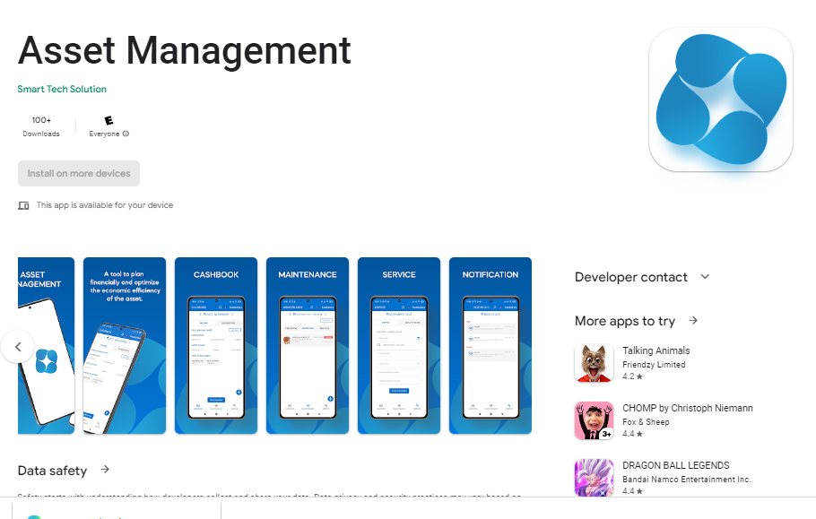

fig) Image of Asset Management app in Google Play

The mobile app has three major sections: a) cashbook, b) maintenance, and c) service. A detailed explanation of all the functions under each section is present in the corresponding section of this manual.:

## a. Cashbook

i. Presents a list of transactions under income and expenditure tabs for the selected month. Cashbooks for different months can be seen by navigating using the date title at the top of the screen.

ii. Users can add actual income or expenditure transactions under different categories. Categories are previously managed from the configuration panel.

iii. Users can close the cash book for a month, locking it for edits after closing. The option of whether the cashbook should be locked is present in the configuration panel.

## b. Maintenance

i. Presents a list of asset components to be maintained for the current year. The user can select between preventive, inspection, or reactive maintenance as assigned from the configuration panel. List for different years can be seen by navigating the app using the date title. The list can be sorted by date, risk score and cost of maintenance.

ii. Elements of the list are clickable to view details of the component together with the details of its maintenance requirement.

iii. Users can add a maintenance log for the component from its detail view and for unlisted maintenance, use the add button to add the maintenance log. Also they can add issue logs by using the same add button and selecting issue log type.

## c. Service

i. Service has 2 sub-sections, supply and quality tests.

ii. Supply is used to add supply records for a date or for a date range.

iii. Quality tests are used to enter quality test results for a date or a date range. The parameters to test can be managed from the configuration panel.

In addition to these features, users can switch between English and Nepali language from the title bar. Users also get notified for adding records in the time interval as set from the configuration panel.

# 5. Using Mobile Application

## 5.1 Login

1. In order to login, the user has to fill in the following details:
   1. 10 Digit authorized mobile number that was assigned from the configuration panel
   2. Passcode should be at least 4 digits, the passcode is created from the configuration panel

***Note:*** *In case you forgot your four digit pin number, please contact the water community administrator, who manages the configuration panel, to reset your pin.*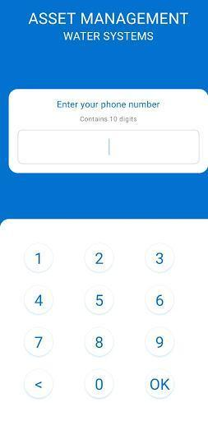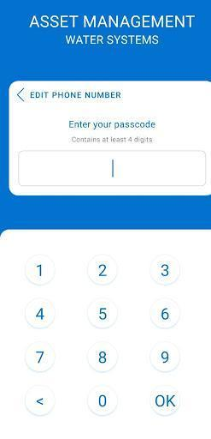

1. After logging in into the mobile app, the user will be able to view different mobile app modules like Cashbook, Maintenance, and Services with different dates in the year of the Water System.
2. This app is available in two languages: English and Nepali. In order to change the language:
   1. User has to click on top of the app where there is an icon of the flag (EN & NP) as per the user preference language.

## 5.2 Mobile App Module

There are mainly 3 tabs in the mobile application. They are Cashbook, Maintenance, and Service.

In order to see and use the Cash Book & Maintenance module, there is a Date Section in the main heading of the app where users can select the date of different years with months and can see all the details regarding cash book & maintenance of that respective year.

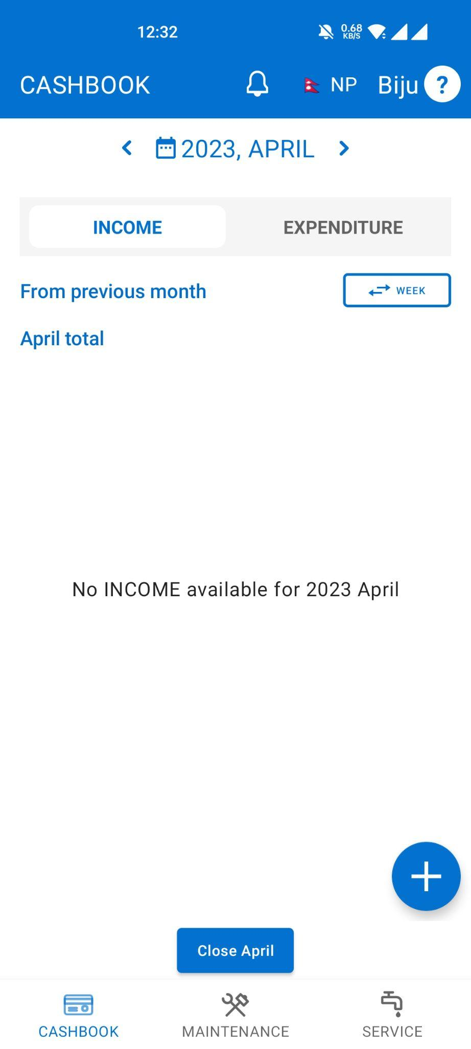

### 5.2.1 Cashbook

Cashbook is the document that records the cash coming in and out for particular dates and in different categories. The cashbook lists all transactions for the current month grouped under income and expenditure tabs. To add a new transaction, the user taps on the Plus (+) button. A pop-up like a box will appear in order to add income and expenditure.

#### 

#### 5.2.1.1 Add Income

While adding the income, the following details are required:

1. Select category: The user has to select a category from the list of multiple income categories. The income categories can only be created in the configuration panel. If an app user cannot find the relevant category, the user should contact the administrator to add the required category.
2. Select date: The user has to click on the calendar icon and needs to select the date
3. Income Title: The User has to add the income title compulsory. The income title is a reference (a specification in words or a code) a user can give to the income category (e.g. Water sold Ms. Rahana; Water bill of HH no.35; Subsidy installment 2).
4. Income Amount: The User has to add the income amount as per income title
5. Water Sold: The User has to add the water sold in liters. Users need to enter this field only when they are adding water sales. (Water sales selected as the category for income).
6. Save the added data by clicking on the SAVE Button.

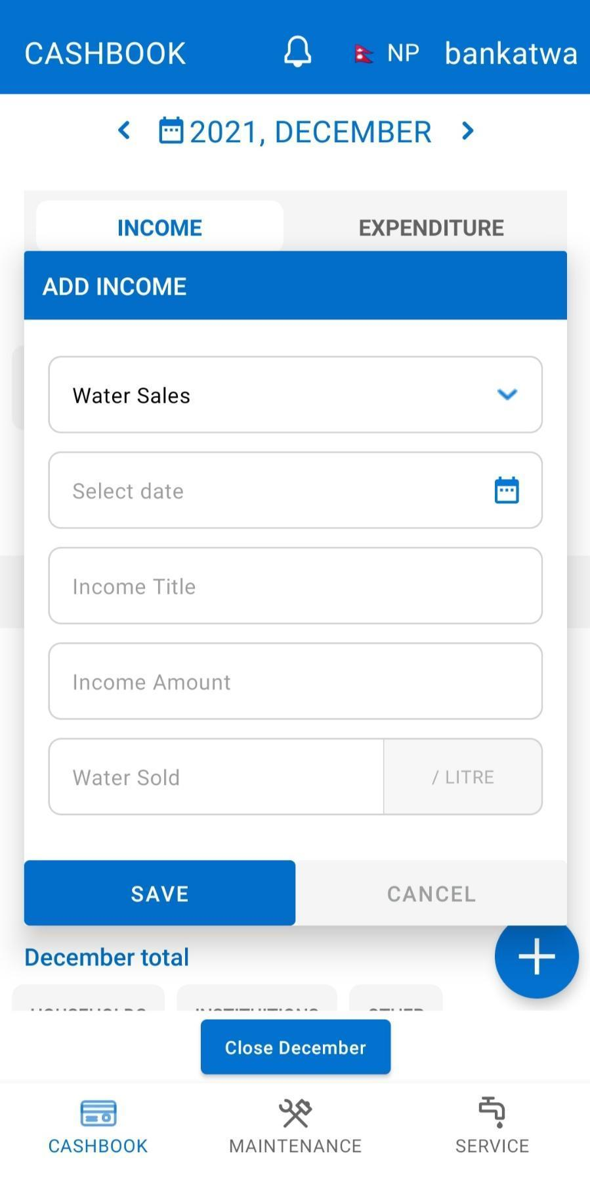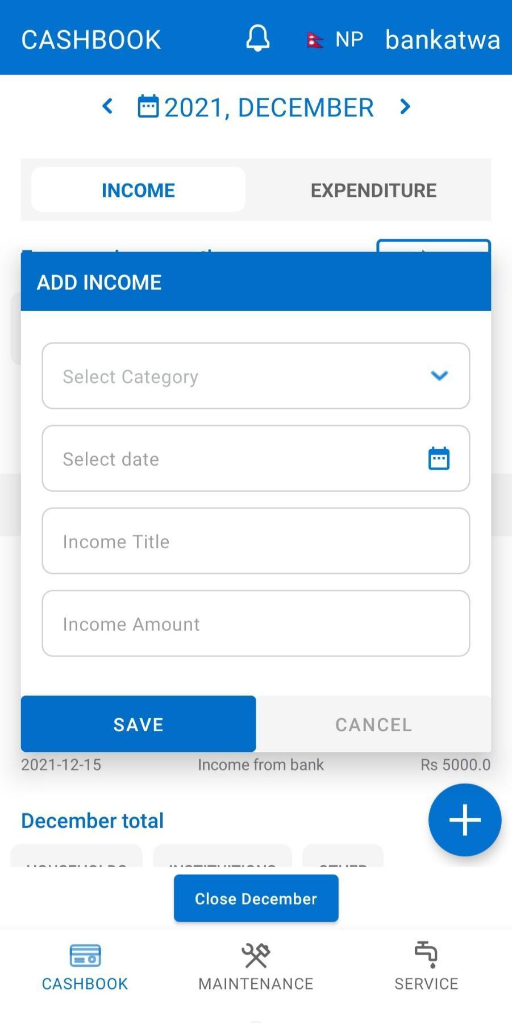

#### 

#### 

#### 

#### 

#### 

#### 

#### 

#### 

#### 

#### 5.2.1.2 Add Expenditure

While adding expenditures , the following details are required:

1. Select category: The user has to select a category from the list of multiple expenditure categories. The expenditure categories can only be created in the configuration panel. If an app user cannot find the relevant category, the user should contact the administrator to add the required category.
2. Select date: the user has to click on the calendar icon and need to select the date
3. Expense Title: User has to add the expenditure title compulsorily. The expenditure title is a reference (a specification in words or a code) a user can give to the expenditure category (e.g. Material bought for Pipe maintenance; Paid for transportation of the material; Paid wages to the labor).
4. Expense Amount: The user has to add the expense amount

If the user selects the “Maintenance” category from the given list then only he/she can also add the cost separately for the segregated cost of maintenance

* Labor Cost: Refers to the labor costs for providing a one-time maintenance/ repair to the system component.
* Consumable Cost: Refers to all materials costs for a one-time maintenance/repair to the system component.
* Replacement Cost: Add the total costs of completely replacing the system component (so both labor & material costs).

**NOTE:** The same component should be added twice if it has both repair and replacement needs. E.g., Valve needs to be replaced once every 5 years. Then you should add the component and include replacement costs and keep Labour and Consumable costs at 0 (zero). Valve also needs lubrication every 3 months. Then you should add the same component again and insert the Labour and Consumable costs of that, but keep Replacement cost at 0 (zero).

1. Remarks: The User has to add remarks. Remarks are helpful when looking back in time about a specific income, expenditure or issue within the water system. The user is encouraged to add remarks no matter how insignificant this may seem.

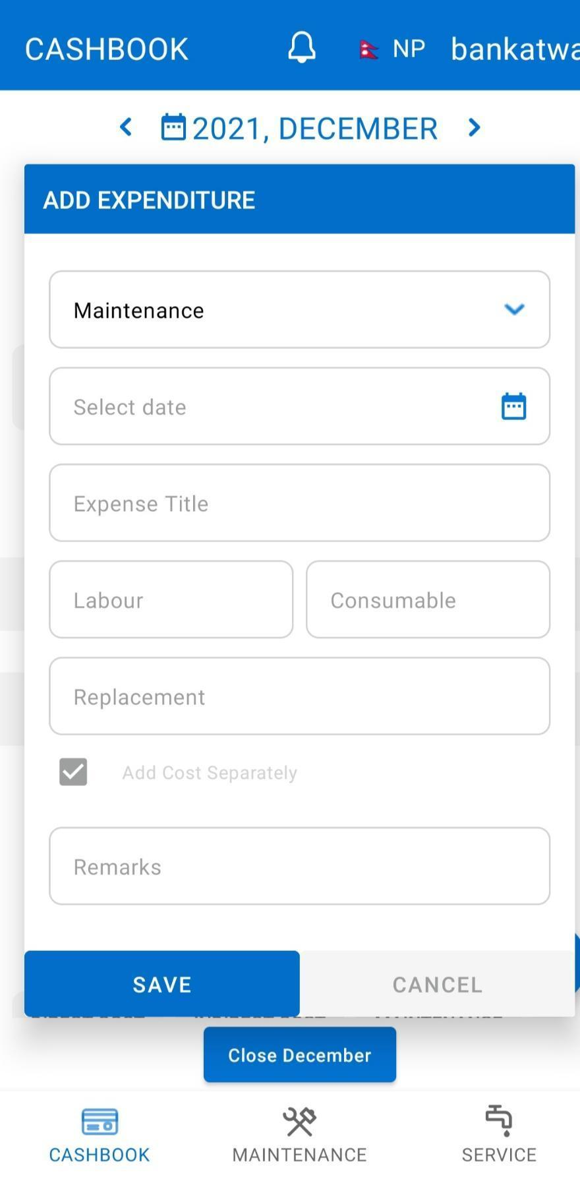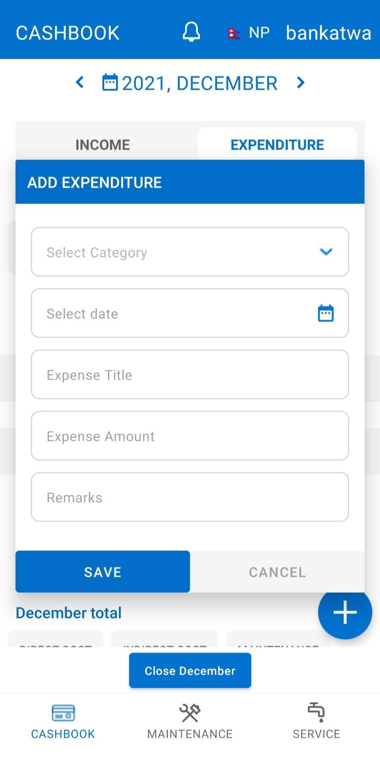

#### 

#### 

#### 

#### 

#### 

#### 

#### 

#### 5.2.1.3 Other functions in Cashbook

1. Cashbook for the next or previous months can be selected by using **<** and **>** navigation links at the either side of the month label.
2. On the right side of the app, there is a button to filter between month and week. By using this button, the user can view the income and expenses separated by month or by week.

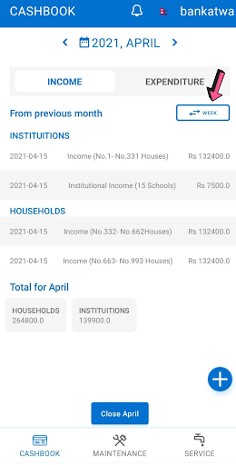

1. There is a Close button at the end of the Cashbook tab where users can confirm closing the cashbook for the selected month. Once the closing is made, the user will not be able to add the transaction for the particular month.



1. While Closing Month users can also capture or select and submit the image of the cashbook for the given month. The submitted image of the cashbook will be available on the Dashboard’s Cashbook section for the administrator to visualize and reconcile the transactions.
2. **NOTE:** The accounts closed cannot be reverted from the app. Please contact the administrator of the water system’s configuration panel if the closing for the month is done mistakenly.

### 

### 

### 5.2.2 Maintenance

In the maintenance tab, there are mainly three sections,Preventive, Inspection and Reactive and the option to add Non-scheduled Maintenance.

* Reactive: One reacts when the asset breaks down or fails.
* Inspection: One uses regular pre-planned inspections to determine the state of the assets, and plan maintenance based on that.
* Preventive: One does maintenance when a certain specified parameter reaches a certain value/level (e.g. replacement of a valve after 10,000 liters or water supplied).

Each section in Maintenance consists of predefined maintenance schedules for asset components (which have been entered through the configuration panel). Users can add the maintenance (or issue) logs for each asset by filling up the following required data.

* Issue log: Used to log details about failures encountered at the water system site, which require reactive or unplanned maintenance in the (near) future.
* Maintenance log: Used to log actual maintenance executed at the water system site. The cost incurred here will be reflected in the Actual Expenditure (Finance Visualization) and Actual Maintenance Cost (Maintenance Data Visualization). Cost included in Total Cost will be visualized in Actual Expenditure (Finance) and Actual Unsegregated (Maintenance). Segregated costs Consumable, Labour, and Replacement will be visualized in Actual Expenditure (Finance) as total sum and Actual Consumable, Actual Labour, and Actual Replacement in Maintenance Visualization separately.

Before actual maintenance takes place, an issue log can be marked as Unresolved. After maintenance has been executed, an issue log can be marked as Resolved.

The scheduled maintenance is based on the time interval set during the maintenance cycle in the configuration panel. E.g. If the occurrence of the maintenance is every 6 months in a year, the option available to fill the log will be 2 in number for that particular year and coming years. This can be seen in the mobile app when the user clicks Add after selecting the task. There will be an option available < 1 OF 2>. Users can navigate by clicking < or >.

When the pre-scheduled maintenance logs are saved, they will be available in the mobile app for viewing. If there is more than one log available for the particular maintenance task, the user can navigate the logs by selecting the maintenance task. Users will be able to edit the pre-scheduled logs if required. For the non-scheduled maintenance logs, the saved logs will be available only in the configuration panel. Both the maintenance and issue logs are available in the configuration for viewing and modification. They are under the section maintenance > Actual maintenance (logs).

#### 5.2.2.1 Preventive

In the preventive section, there are multiple lists of components (previously defined in the configuration panel) as per the maintenance schedule by interval day/month/year. The user has to add the maintenance log by clicking on one of the maintenance lists. If the user cannot find a list of components, he/she should communicate it to the water manager in charge of the configuration panel.

1. Click on the ADD button from one of the lists
2. After clicking on the ADD button, a pop-up that contains a form appears, where data on preventive maintenance can be logged. Following data are required to fill in the log: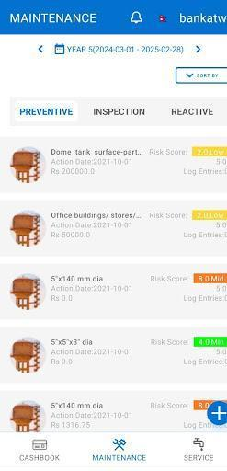
   1. Select the date: the user has to click on the calendar icon and needs to select the date
   2. Time Required: The user has to add the time that was required for the maintenance of the specific asset. Stated in days/month/year as Time Unit.
   3. Total cost: The user has to add the total cost of the maintenance without any cost segregation that will occur for the particular maintenance task.

There is a box: Add cost separately where the user has to click on that box and three different fields will appear. These fields are available there in order to add the segregated cost of the maintenance components. Go to section 5.2.1.2 to read a more detailed explanation for each field. :

* 1. Labor: User has to add the Labor cost
  2. Consumable: User has to add the Consumable cost
  3. Replacement: User has to add the Replacement Cost
  4. Select the picture: User has to select the picture of the maintenance component. Image should be less than 10 MB.
  5. Remarks: User has to add the remarks. This field is optional and users can add some information if available via this field. Remarks are helpful when looking back in time about a specific income, expenditure or issue within the water system. The user is encouraged to add remarks no matter how insignificant they may seem.
  6. Save the added data by clicking on the SAVE LOG.

#### **5.2.2.2 Inspection**

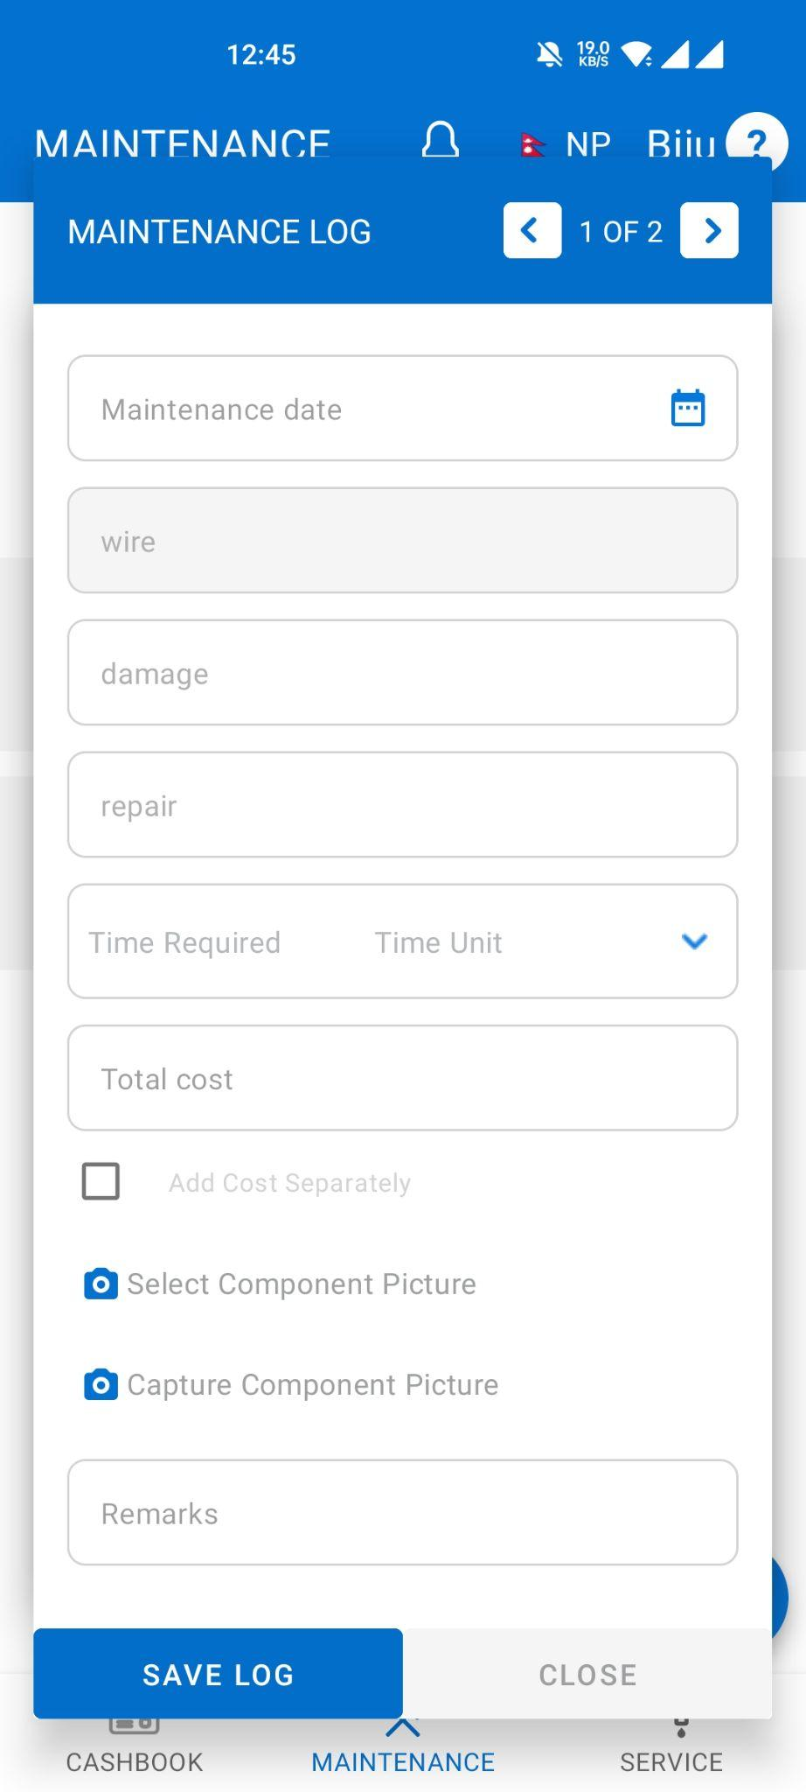

In the Inspection section, there are multiple lists of components (previously defined in the configuration panel) as per the maintenance scheduled by interval day/month/year. The user has to add the inspection log by clicking on one of the maintenance lists. If the user cannot find a list of component, he/she should communicate it to the water manager in charge of the configuration panel.

1. Click on the ADD button from one of the lists
2. After clicking on the ADD button, a pop-up like a form appears where the inspection maintenance log has to be added. Following data are required to fill in the log:
3. Select the date: the user has to click on the calendar icon and needs to select the date
4. Time Required: The user has to add how often is the maintenance required for the specific asset. Stated in days/month/year.
5. Total cost: User has to add the total cost of the maintenance without any cost separation
6. There is a check box: Add cost separately where the user has to click on that box and three different fields will appear. These fields are available there in order to add the segregated cost of the maintenance components. Go to section 5.2.1.2 to read a more detailed explanation for each field.Labor: User has to add the Labor cost
7. Consumable: User has to add the material cost
8. Replacement: User has to add the Replacement Cost
9. Select the picture: User has to select the picture of the maintenance component. Image should be less than 10 MB.
10. Remarks: User has to add the remarks. Remarks are helpful when looking back in time about a specific income, expenditure or issue within the water system. The user is encouraged to add remarks no matter how insignificant they may seem.
11. Save the added data by clicking on the SAVE LOG.

#### **5.2.2.3 Reactive**

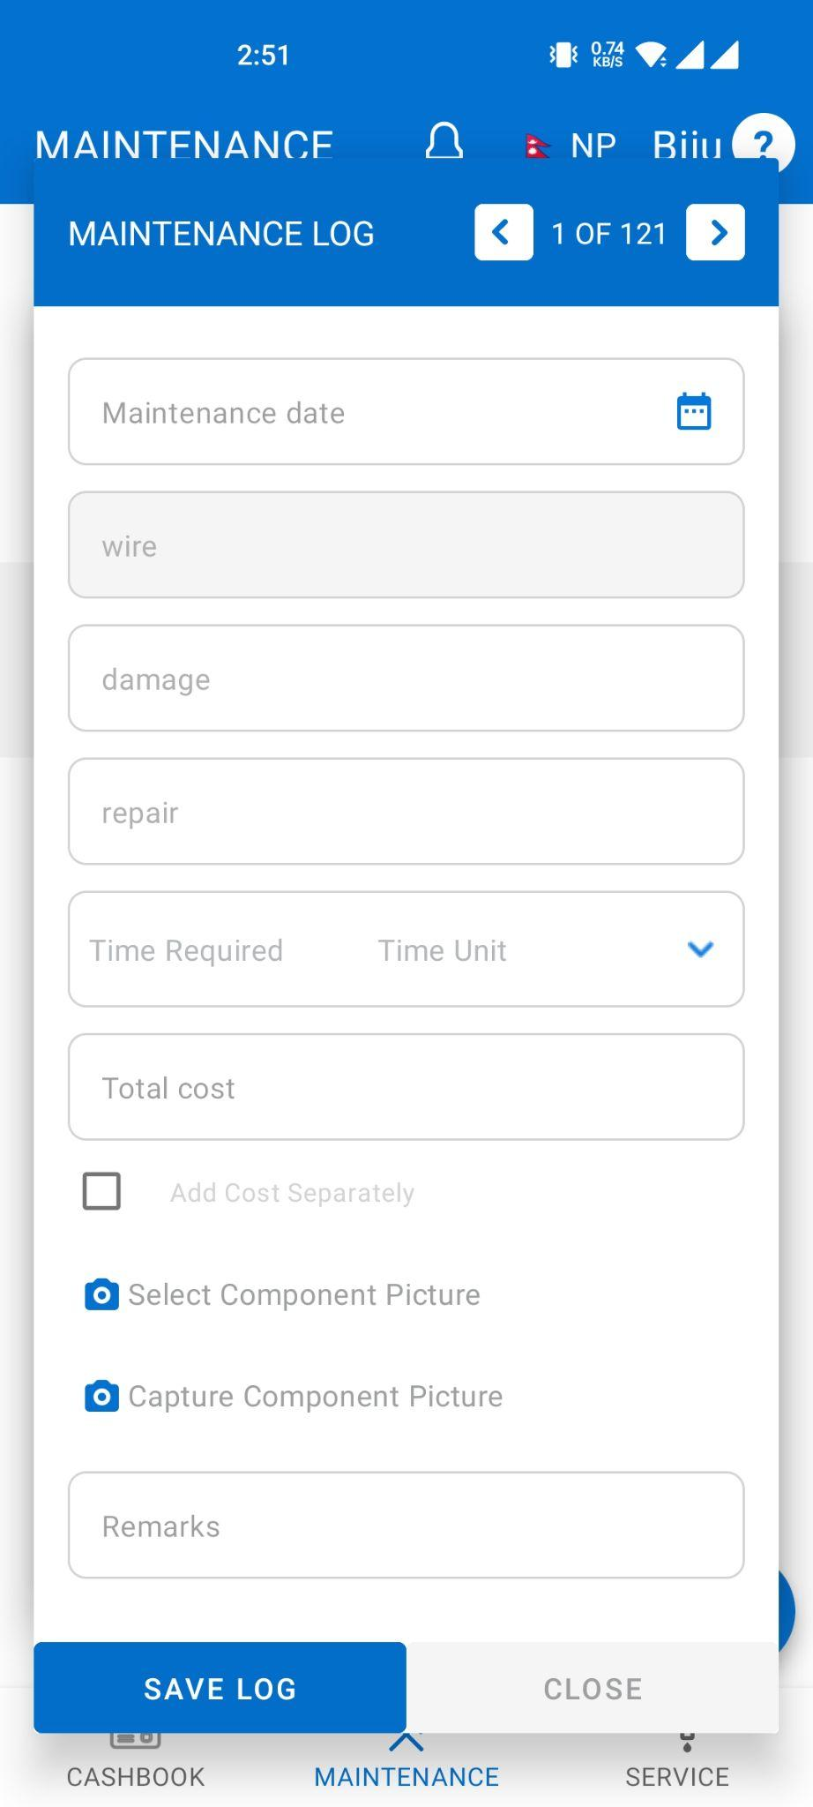

In the Reactive section, there are multiple lists of components (previously defined in the configuration panel) as per the maintenance scheduled by interval day/month/year. The user has to add the maintenance log by clicking on one of the maintenance lists. If the user cannot find a list of component, he/she should communicate it to the water manager in charge of the configuration panel.

1. Click on the ADD button from one of the lists
2. After clicking on the ADD button, a pop-up like a form appears where the reactive maintenance log has to be added. Following data are required to fill in the log:
3. Select the date: The user has to click on the calendar icon and needs to select the date
4. Time Required: The user has to add how often is the maintenance required for the specific asset. Stated in days/month/year.
5. Total cost: The user has to add the total cost of the maintenance without any cost separation
6. There is a check box: Add cost separately where the user has to click on that box and three different fields will appear. These fields are available there in order to add the segregated cost of the maintenance components. Go to section 5.2.1.2 to read a more detailed explanation for each field. Labor: User has to add the Labor cost only
7. Consumable: User has to add the consumable cost only
8. Replacement: User has to add the Replacement Cost only
9. Select the picture: User has to select the picture of the maintenance component
10. Remarks: User has to add the remarks (optional). Remarks are helpful when looking back in time about a specific income, expenditure or issue within the water system. The user is encouraged to add remarks no matter how insignificant they may seem.
11. Save the added data by clicking on the SAVE LOG.

#### 

#### 

#### 

#### 

#### 

#### 

#### 

#### 

#### 

#### 

#### 

#### 

#### **5.2.1.3 Other functions in Maintenance**

1. On the maintenance tab, there is a Plus(+) Button where the user has to add Not Scheduled Maintenance. After clicking on the Plus(+) Button, a pop-up form appears

where the not-scheduled maintenance log has to be added. 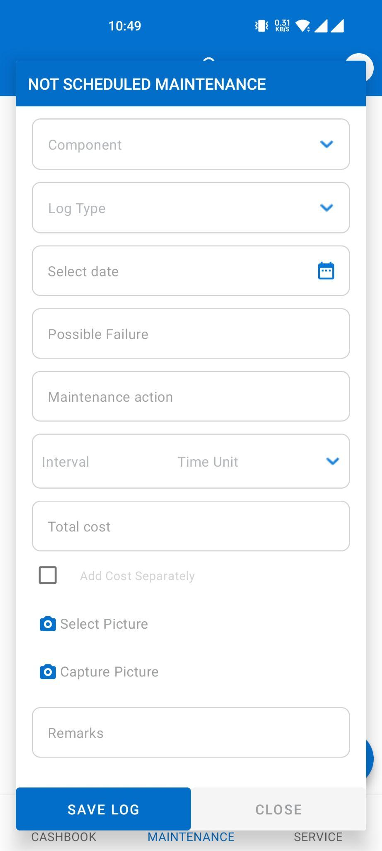

* 1. Component: The user has to select one of the maintenance components from the given component lists(previously defined in the configuration panel).If the user cannot find a list of component, he/she should communicate it to the water manager in charge of the configuration panel.
  2. Log Type: Choose the log type either “Maintenance log” or “Issue log”
  3. Select date: the user has to click on the calendar icon and needs to select the date
  4. Possible failure: User has to add the possible failure of the maintenance component
  5. Maintenance action: User has to add the maintenance action of the maintenance component
  6. Time Required: The user has to add how often is the maintenance required for the specific asset. Stated in days/month/year.s
  7. Total cost: The user has to add the total cost of the maintenance without any cost separation

There is a check box: Add cost separately where the user has to click on that box and then three different fields will appear. These fields are available there in order to add the segregated cost of the maintenance components. Go to section 5.2.1.2 to read a more detailed explanation for each field.

* 1. Labor: User has to add the Labor cost only
  2. Consumable: User has to add the consumable cost only
  3. Replacement: User has to add the Replacement Cost only
  4. Select the picture: User has to select the picture of the maintenance component
  5. Remarks: User has to add the remarks
  6. Save the added data by clicking on the SAVE LOG.

1. On the Right Side of the app, there is a SORT BY button: Action Date, Est. Cost & Risk Score where the user can view the maintenance list by clicking on the SORT BY Button.

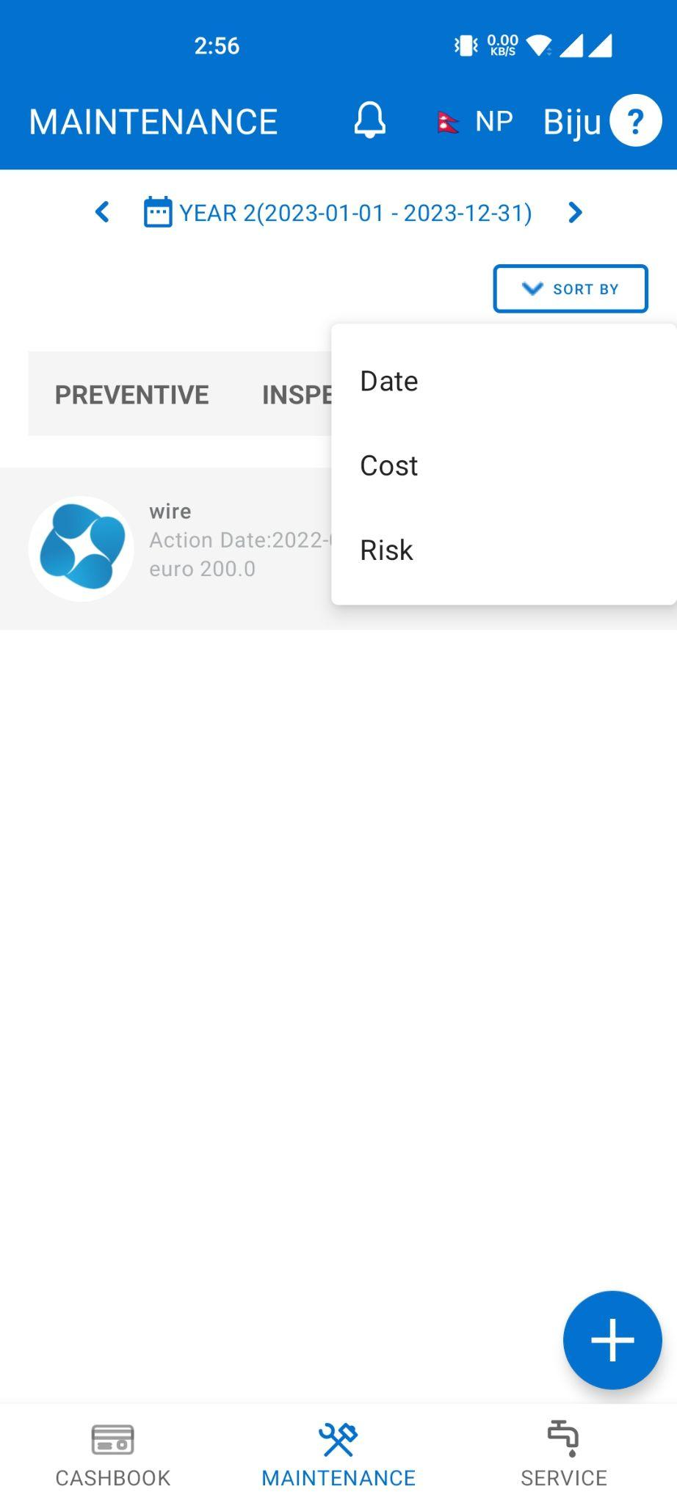

### 5.2.3 Service

In the Service tab, there are mainly two sections, Supply & Quality Tests where users can add supply of water and quality tests as per the Water System.

#### 

#### 5.2.3.1 Supply

In the supply section, the user has to add the water supply record. In order to add the water supply records, the following data are required:

1. Start Date: The user has to click on the calendar icon and needs to select the Start date.
2. There is a check box: Add record for a date range where the user can add the water supply records for an interval . If the checkbox is not checked, the record will be for the single day and if checked will be for date range. Example: (From 11th Oct- 12th Dec). User has to click on that box and then another Field for the End date will appear on the same format.
   1. End date: the user has to click on the calendar icon and needs to select the End date.
   2. Total Daily Supply: Users have to add the total daily supply of the water in Liters. Either end date is applied or not, the volume of water supplied will be for a single day only. If the end date is applied and the date range is for 5 days and 500 liters of water supplied, total daily supply will be 500 liters per day for 5 days, thus in total 2500 liters.
   3. Save the added data by clicking on the SAVE RECORDS.

The data saved in Water Supply will be available in Service Supply Visualization in Web Dashboard. The amount of water supplied in liters will be used to calculate the volume of non-revenue water based on the water sales under Income.

#### 

#### 5.2.3.2 Quality Tests

1. In the Quality Tests section, the user will be able to add the water test results. In order to add the water test results, the following data are required:
   1. Start Date: the user has to click on the calendar icon and needs to select the Start date.
2. There is a box: Add a record for a date range where the user can add the Quality test records for the interval of the date. Example: (From 11th Oct- 12th Dec). The user has to click on that box and then another Field for the End date will appear on the same form.
   1. End date: the user has to click on the calendar icon and needs to select the End date.
   2. User has to add the water quality test's value of given a parameter (e.g. Turbidity) . The parameters and its units should be previously loaded in the configuration panel. If the user cannot find a parameter, he/she should communicate it to the water manager in charge of the configuration panel.
   3. Save the added data by clicking on the SAVE RECORDS.

The data saved in Quality Tests will be available in Service Quality Test Result in Web Dashboard. The data will help to record the quality of water supplied at different time intervals with reference to the pre-entered NDWQ Standards. The NDWQ Standards can be added from the configuration panel from ‘Service > Water quality test > Quality test parameters’ section.

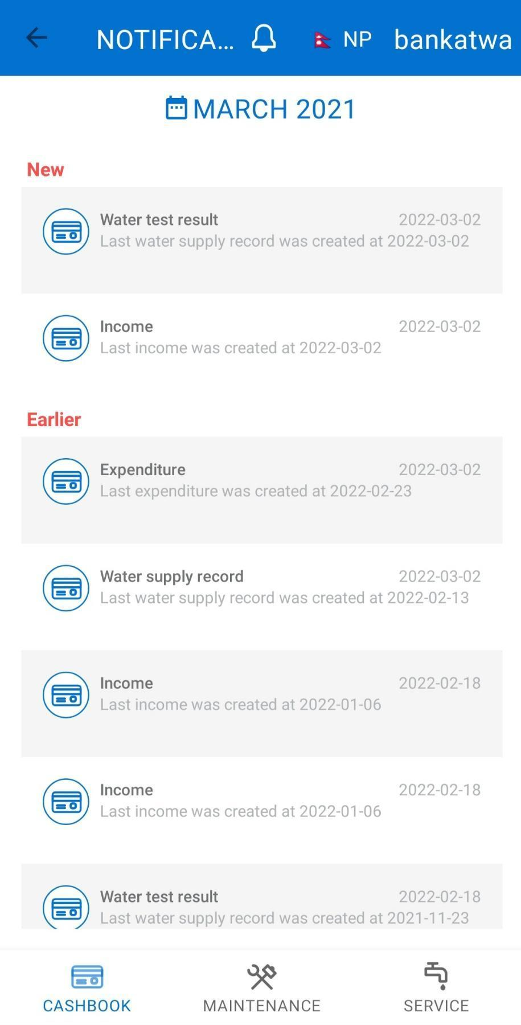

## 5.2 Notification

At the top of the mobile app, there is a Notification icon where the user will be able to view notifications regarding income, expenditure, and service records in a time interval as set from the configuration panel. These notification records are fully managed and maintained from the configuration panel.

XX

For any further information, please contact to the email address below:

Email: [info@smarttech.com.np](mailto:info@smarttech.com.np)

**Thank you**